**ArcGIS automation through**

**scripting with Python**

**2_Interacting with Python**

In this worksheet we cover:

* Where and what is Python and how does it interact with ArcGIS?
* Running from the Windows Command Line
* Running from the Geoprocessing Window
* Clicking a *.py file
* Toolboxes (*.pyt)
* PyCharm

**Step 1: Where and what is Python and how does it interact with ArcGIS?**

|  |
| --- |
|  |
| **Figure 1:** What the ArcGIS Python looks like. |

If you have followed the default installation of Python, and not changed any paths during the installation of ArcGIS on your computer, then you will proceed through this with no issues at all. If changes have been made, then you will likely be able to locate it without any issue.

Locate Windows Explorer and navigate to the root directory of the local system disk (Usually drive C). You are looking for “Python27”, and then click through into the directory, until you end up in a folder that looks like Figure 1. On some occasions you may see several folders each named “ArcGIS10.x”, this usually is due to left over files when the system is upgraded. You should ensure that you locate the **correct** Python version that matches your ArcGIS version.

Once located, double click: 

This will open the Python Window:



Within here you can run any Python command you wish, try entering the commands (press return after each line):

print "Helloooooo!"  
print str(1+1)  
1+3

Congratulations, you have run some Python code! But what about arcpy?

Enter the package:

import arcpy

This tells the Python command prompt that we want to make the entirety of the arcpy package available (usually takes a couple of seconds to run). Once the prompt returns, enter:

arcpy.AddMessage("Hello!")

AddMessage is an arcpy command that essentially works as “print”, but interfaces with ArcGIS in a more detailed way.

**Step 2: Running from the Windows Command Line**

Another method to achieve the same result as the above is to use the Windows Command Prompt, to access this. First, load the Command Prompt, you can usually find it in the Windows Application Menu, or by Windows Key + R, typing “cmd” (no quotes).

Duplicate steps shown in the screenshot below to execute the Python.exe file and bring up the Python command prompt (>>>):



|  |
| --- |
| **Whilst useful to know, you will probably never interact with Python/arcpy in this manner. It is unwieldy, provides no assistance in terms of syntax highlighting and so on.** |

**Step 3: Running from the Geoprocessing Window**

You are far more likely to use Python by interacting with it through ArcGIS Desktop, particularly ArcMap. In this step, bring up an ArcMap window. You can access the “Python” window by either clicking the small icon (see below image), or heading to the drop down “Geoprocessing” and then “Python”.



This window is far more intuitive than using the previous two options:



Try it out with a few commands, note how the Python window gives you a help pane (on the right), and auto-completion of the tool name:





Try making an empty shapefile:

arcpy.CreateFeatureclass_management("D:\Python-Class", "shapefile.shp","POINT")

Next, why not try viewing some other tools that you may have used in the past?

**Step 4: Clicking a *.py file**

This is one of the more common methods of executing a Python script that is linked to an ArcGIS operation. It allows you to create a fully coded file, that you can run in one go, without ever opening ArcMap.

On Github, I prepared a few files within the *Classes > 2_Interacting* folder, download these and store them into a known place:



Try executing Python_Script.py by double clicking on the file.



The result will be a black window that automatically closes, the script has either completed successfully or has run into a problem. But you won’t ever know, as it closes so fast you can’t see it. This is also an issue if you are relying on any error messages or print statements to debug your code.

The way around this is to execute the Python_Script.py file via a Bat file, which will call the Python.exe executable and tell it to run the Python_Script.py file. By adding a pause argument on a second line in the Bat file, you will tell Command Prompt not to close the window:



If you try to run the Bat file provided it may not complete if you are storing your files in a different location to me, so edit the file (Right click > Edit) and adjust the location of the script or the Python.exe executable.

**Step 5: Toolboxes (*.pyt)**















**Step 6: PyCharm**

My favoured method of interacting with Python and arcpy for development, revising and executing code is to use the IDE (integrated development environment) ***PyCharm***. In this section, I take you through the “portable” version of PyCharm (this is a version that you can run from a USB stick, or on a computer where you don’t have installation rights). However, if you are using your own computer, you can install as normal and I would suggest downloading it from: <https://www.jetbrains.com/pycharm/download/>, you can use the “Community Edition”, but if you want additional features, you can download the “Professional Edition” and apply for a free license (https://www.jetbrains.com/student/).

First download the Portable versions of Atom (not covered here, but is a nice text editor to replace Notepad), PyCharm_Portable.exe and Git_Portable.exe. These are “portableapps”, so you need to execute them and install them on your USB drive, or in a location that you have write access to.



\

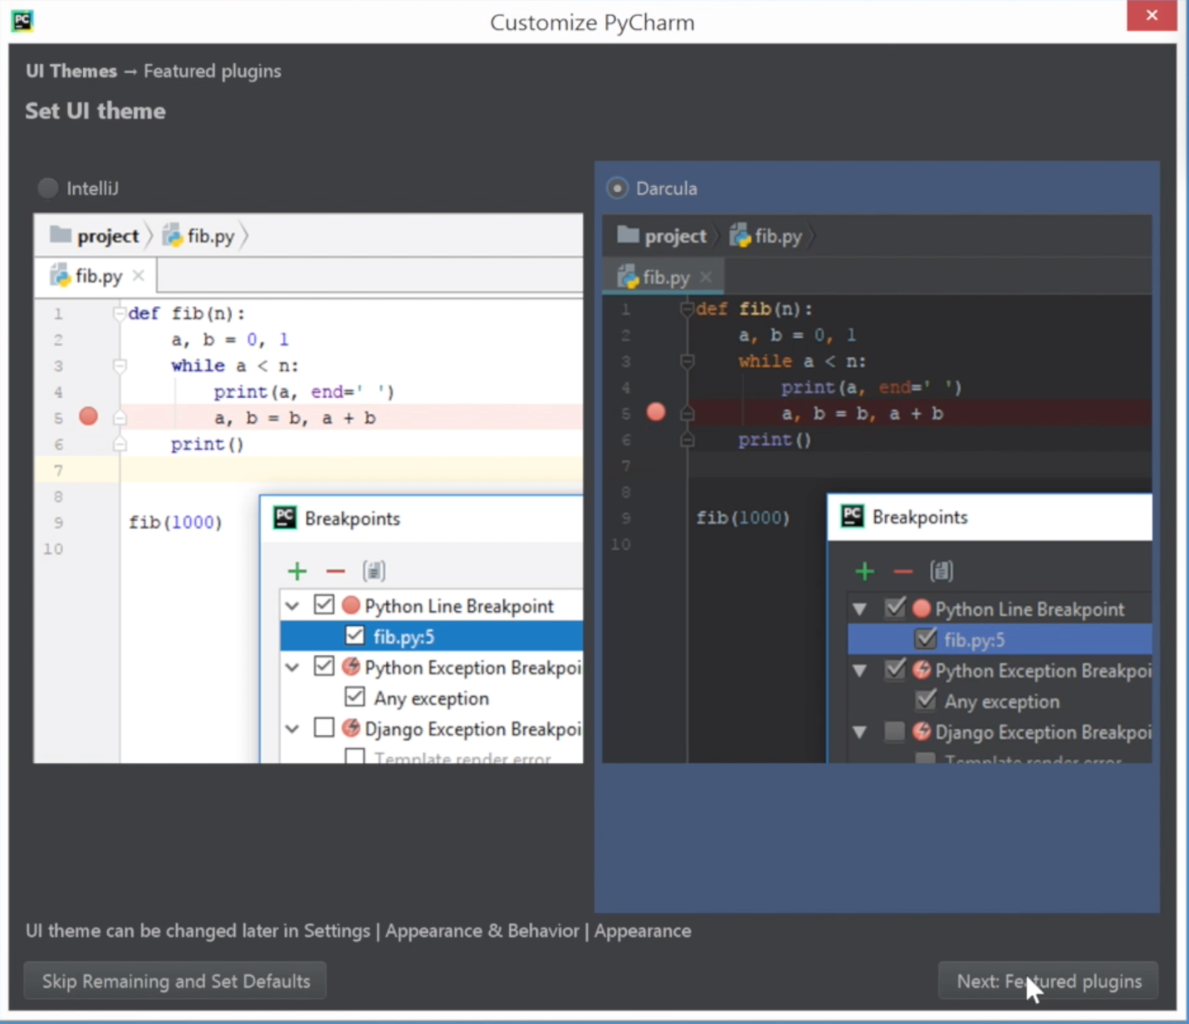

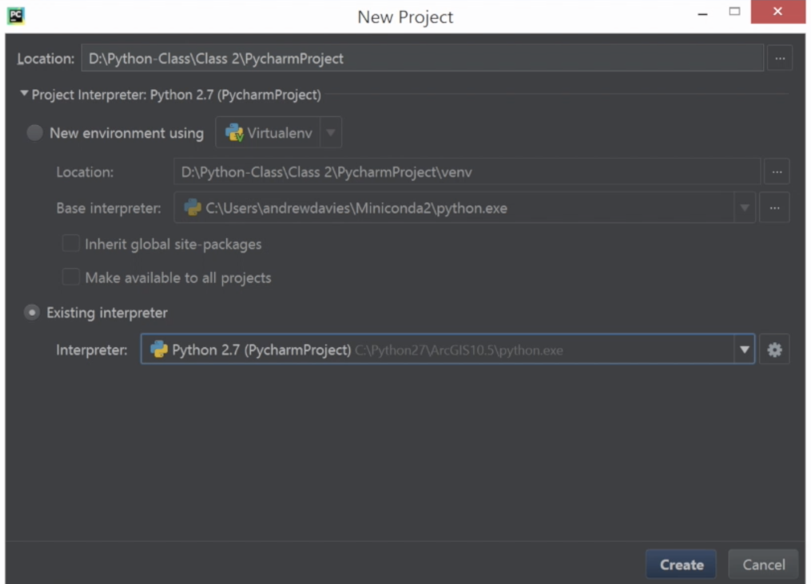





print "Helloooooo!"  
print str(1+1)  
1+3

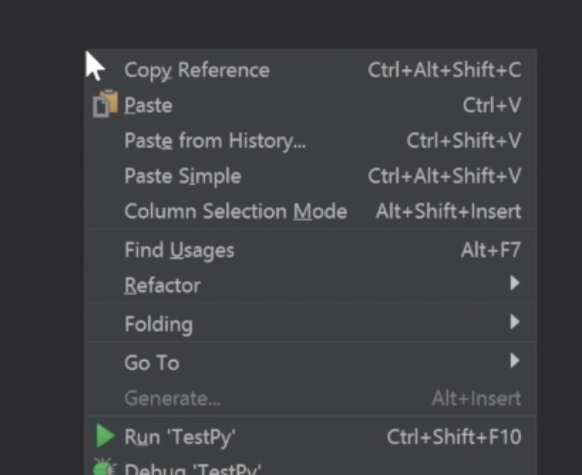



import arcpy  
arcpy.CreateFeatureclass_management("D:\Python-Class", "shapefile2.shp","POINT")

arcpy.CreateFeatureclass_management("D:\Python-Class", "shapefile2.shp","POINT")

Add Git and Github functionality to PyCharm





